All residents of Boxley Parish
are invited to attend the

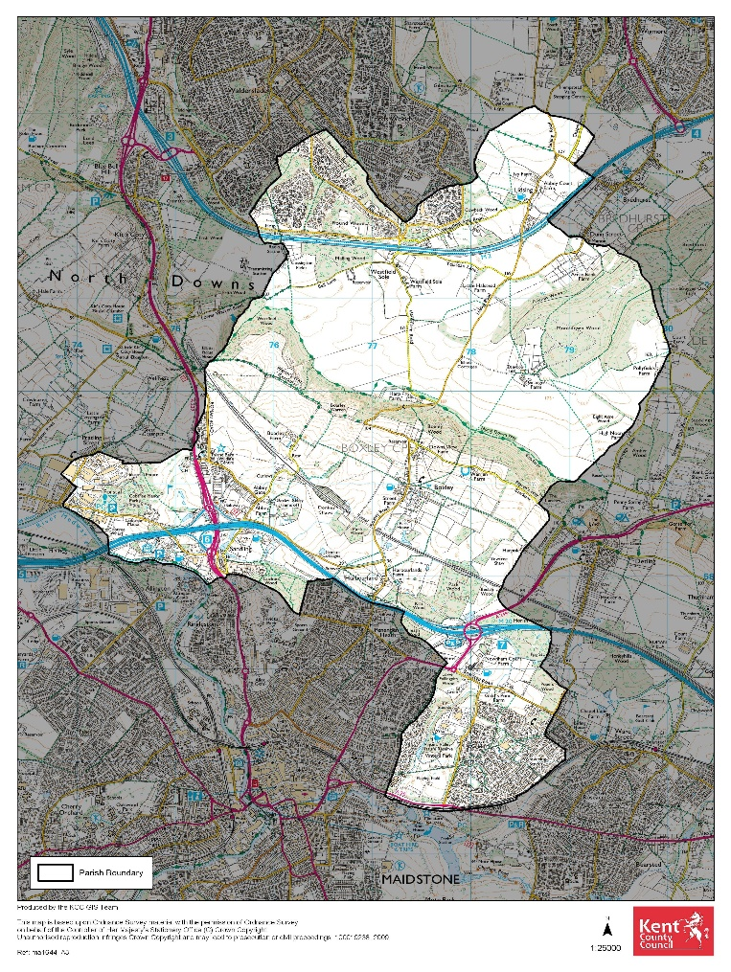
ANNUAL MEETING OF THE PARISH
Grove Green/ Weavering
Boxley
Sandling/Forstal
Lordswood
Walderslade
Boxley Parish
Tuesday 2 April 2024, at 18:30
At Weavering Village Hall, Weavering Street, ME14 5JP

Agenda
- Apologies.
- Minutes of the Annual Meeting of the Parish held on Tuesday 2 May 2023.
- Matters arising from the minutes.
- Boxley Parish Council Chairman’s Report.
- To receive the Audited accounts for the year end March 2023.
- To receive reports from local organisations.
- To receive questions from residents (to be sent to the Clerk in advance).

Daniela Baylis, Clerk to the Council

Vinters Park

Beechen Hall, Wildfell Close, Walderslade, Chatham, Kent. ME5 9RU
01634 861237
clerk@boxleyparishcouncil.org.uk
Clerk: Daniela Baylis
Assistant Clerk: Heidi Pearson
Finance Assistant: Nichola Carter

www.boxleyparishcouncil.org.uk

